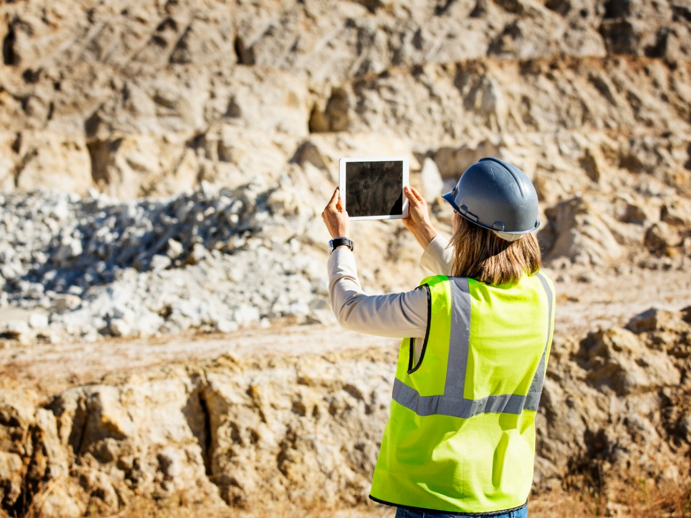
Department of Conservation
Middle School Lesson Sequence: Protecting our Natural Resources
http://www.conservation.ca.gov/dlrp

California Next Generation Science Standards:

MS-ESS3-3. Apply scientific principles to design a method for monitoring and minimizing a human impact on the environment.*[Clarification Statement: Examples of the design process include examining human environmental impacts, assessing the kinds of solutions that are feasible, and designing and evaluating solutions that could reduce that impact. Examples of human impacts can include water usage (such as the withdrawal of water from streams and aquifers or the construction of dams and levees), land usage (such as urban development, agriculture, or the removal of wetlands), and pollution (such as of the air, water, or land).]
MS-ESS3-4. Construct an argument supported by evidence for how increases in human population and per-capita consumption of natural resources impact Earth's systems. [Clarification Statement: Examples of evidence include grade-appropriate databases on human populations and the rates of consumption of food and natural resources (such as freshwater, mineral, and energy). Examples of impacts can include changes to the appearance, composition, and structure of Earth’s systems as well as the rates at which they change. The consequences of increases in human populations and consumption of natural resources are described by science, but science does not make the decisions for the actions society takes.]
California Environmental Principles and Concepts:

Principle I—People Depend on Natural Systems. The continuation and health of individual human lives and of human communities and societies depend on the health of the natural systems that provide essential goods and ecosystem services.
Principle II—People Influence Natural Systems. The long-term functioning and health of terrestrial, freshwater, coastal and marine ecosystems are influenced by their relationships with human society.
Principle III—Natural Systems Change in Ways that People Benefit from and Can Influence. Natural systems proceed through cycles that humans depend upon, benefit from and can alter.
Principle IV—There are no Permanent or Impermeable Boundaries that Prevent Matter from Flowing Between Systems. The exchange of matter between natural systems and human societies affects the long-term functioning of both.
Principle V—Decisions Affecting Resources and Natural Systems are Complex and Involve Many Factors. Decisions affecting resources and natural systems are based on a wide range of considerations and decision-making processes.

Anchoring Phenomenon for lesson sequence: Human need and use of natural resources change landscapes.

Lesson 1 – Aggregate Mining

Learning Objective: Students will investigate where aggregate mines exist near their community to support construction and development.

Investigative Phenomena: More densely populated communities have more and larger aggregate mines.

Guiding Question: How is the expansion of human population growth and urban development impacting the environment?” [More specifically, how is the expansion of human population growth and urban development impacting our ability to protect our mineral resources?’]

Lesson Implementation Timeframe: 2-3 (50-60 minute) class period

Classroom Resources and Materials:
- Protecting our Natural Resources Lesson 1 PowerPoint Beta
- Student Handout: MS L1 H1 Card Sort Activity
- Student Handout: MS L1 H2 Cause_Effect Chart
- Student Handout: MS L1 H3 Aggregate Map
- Student Handout: MS L1 H4 Decision Making Matrix

Procedures:

Engage

- Display slide 1. Welcome students and introduce the lesson sequence by identifying the guiding question, “How is the expansion of human population growth and urban development impacting the environment?” More specifically to this lesson, how is the expansion of human population growth and urban development impacting our ability to protect mineral resources?

- Display slide 2. Ask students to make observations of the “California’s Population” graph from March 2017. To review the full report from the Public Policy Institute of California (PPIC) go to www.ppic.org. Tell students to write down their observations about the graph by responding to the following two questions:

  - What pattern do you see in the above data in our California population? The population continues to grow.
  - What questions do you have about this information? Students’ possible examples may include: Why has the population continued to grow? Why is the population growth gradual at times? Why is the population growth steeper at times? Does the population growth appear to be slowing down?

Ask students to share their observations with a partner. After allowing each student to share with their partner, request a few volunteers to share their answers with the class.

- Display slide 3. The advancement of technology and medicine has allowed people to live longer and our population to continue to grow. Share with students that their questions are an opportunity to investigate how human population growth might impact our community and environment.

Tell students that the guiding question for this lesson is, “How is the expansion of human population growth and urban development impacting the environment?” Ask students to brainstorm some possible effects of human population growth and urban development on the environment. Share an example of an effect of human population growth by providing the example that humans build homes that disrupt the natural environment for animals. Agriculture, mining, building dams, driving cars, cutting forests, fishing, and constructing homes are all possible answers.

Explore

- Display slide 4. Ask students to work in a group of four students and pass out a set of cards with examples of activities caused by humans that have an effect on the environment. Tell students to review the cards and discuss how each term benefits humans and how each might impact our environment.

These are some sample student responses for each human activity – NOT an exhaustive, comprehensive list:
Activity | Benefit to Humans | Impact on Environment
Agriculture | Food | Loss of top soil and habitat. Increased usage of water
Industry | Energy, technology, transportation, food and other manufacturing production | Pollution and material usage
Dams | Water storage and Energy Production (Hydroelectric) | Habitat loss
Housing/Development | Shelter | Loss of habitat. Increase in reflecting heat back into the atmosphere. Decrease in groundwater recharging.
Mining | Raw materials for construction of roads and homes | Loss of habitat
Transportation | Travel | Fossil fuel usage (gas)
Recreation | Fun | Loss of natural space
Fishing | Food | Loss of species
Waste | Packaging for safe food | Pollution leading to loss of biodiversity
Sewage Treatment | Decrease disease transmission | Raw sewage released in the ocean or stored in landfills.
Cattle Grazing | Food | Habitat loss. Water usage.
Forestry | Construction materials | Loss of biodiversity

- Display slide 5. Review the Earth’s systems from grade 5 (5-ESS2-1) by showing VA#2 Earth’s Climate System Visual Aid from the Education in the Environment Initiative curriculum (https://www.calrecycle.ca.gov/eei/unitdocs/earthscience/e4c/e4cvapf.pd) or use review the information on the slide to define the different Earth systems

  - Geosphere – all the rocks and landforms on the surface and the ocean floor of the earth.
  - Hydrosphere – all the water on and around the earth’s surface.
  - Atmosphere – gas layer surrounding the earth.
  - Biosphere – all the living organisms on earth.

- Display slide 6. Ask students to revisit their labeled cards with human activities written on them. Tell students to consider how each human impact affects the different earth systems. Share an example by saying, “Agriculture impacts the geosphere because it replaces native plants and it has an impact on the hydrosphere because it uses water from the surface and ground.”

- Display slide 7. Distribute “Human Impacts on the Environment: Cause and Effect Chart” (Handout 1). Instruct students to work in groups and fill out as much of the chart as possible. They are just exploring these ideas for the teacher to identify prior knowledge so the chart does not need to be complete. Provide enough time for students to discuss and partially complete the chart.

Share with students that they will be watching a video by Paul Anderson who will provide some examples of human impacts on Earth systems in a video. Students will record information from the video on the handout (Handout 1) that describes the effects of human impacts.

Explain

- Display slide 8. Begin the video on “Human Impacts on Earth Systems” by Paul Anderson (https://youtu.be/lrxZ_UqQKyI). Model how to complete the information using the handout by pausing the video approximately 45 seconds into the video and ask students to complete how human are impacting the geosphere. Ask a student to share their answer (Human Impact Example (Cause) Agriculture & Mining and Effect: Soil loss). Stop the video at 2:18.

- Display slide 9. Provide students with additional time to complete the handout. Review student answers by asking students to share their findings with another partner. Invite individual students to share their answers with the whole class.

Elaborate

- Display slide 10. The California Department of Conservation has five divisions that provide services to foster the wise use and conservation of energy, land and mineral resources in California. We will be using some of the tools that scientists at the CA Department of Conservation have created to monitor land use, agriculture, geothermal resources, oil, gas, mines, mineral, geology, and hazards.

- Display slide 11. Share with students that concrete used in roads and construction materials are made from rocks and sand called aggregate. Aggregate is mined locally when possible because it can be very expensive to transport heavy rock, sand, and other crushed stone.

- Display slide 12. Mining aggregate is important to the California economy to keep pace with new construction in a community. We can identify where mines are located across the state by using the California Department of Conservation Mines Online map. Tell students to explore the map before asking them to investigate where the nearest open mine exists near their community.

To access the map, go to the Department of Conservation website: https://maps.conservation.ca.gov/mol/index.html. Open up the “Mines Online” map. Read about mines online (MOL) and accept the data disclaimer.

To identify the nearest mine, go to the left-hand side of the map and find the search box and type in your school address in the “Find address or place” space. Zoom in or out by using the + or – buttons on the left-hand side of the map to orient yourself to the map.

- Display slide 13. Help students find the map legend by selecting the icon at the top, right-hand side of the map. The legend will define the relative size of the circle by how many acres are disturbed. Ask students to double click on a mine and select the arrow to view more information about the mine, including the mine status (active or not active) and primary product (sand, gravel, fill dirt, clay etc..). Additional information is provided in the text box.

- Display slide 14. The California Department of Conservation created a map that represents the expected demand for aggregate based on historic growth in over 30 study areas. The map uses a pie graph to represent the demand for aggregate versus the available aggregate in reserves that is permitted. Pass out Lesson 1, Handout 3 Aggregate Map for students to analyze.

- Display slide 15. Ask students to analyze the cities that have been studied. The data is represented as a pie graph. What claim can they make from analyzing the data? What data can students use to support their claim? What do they think is the reason for their data and evidence? Provide students with the following frame to develop their claim with evidence and a reason for their data:
- Claim
- Evidence
- Reasoning
Evaluate

- Display slide 16. Create groups with 2-3 students. The students have analyzed the expected demand in 50 years for aggregate based on historic growth in over 30 study areas. Now it is time to propose a solution by considering five possible scenarios:
- Continue mining of aggregate at the current rate
- Decrease mining of aggregate
- Stop all mining of aggregate
- Increase mining for aggregate in a few cities
- Start new mining for aggregate in all cities.

Distribute Lesson 1, Handout 4 “Mining Consideration Decision-Making Matrix”. Assign each group one of the considerations. Tell each group to discuss the assigned consideration (cause), the effect or impact of the consideration, and possible recommended solution(s). Allow students enough time to complete all three columns of information.

Ask the groups to pair up and share their information with another group who was assigned the same consideration. This step is optional if there are not enough students to make larger groups. Ask students to exchange their information by presenting their answers to the class.

Finish this activity by asking volunteers or randomly selecting students to share their answers with the class. Tell students to closely listen to each presentation and write down information into the remaining space on their “Mining Considerations Decision-Making Matrix”.

Lesson 2 – Life Cycle of a Mine

Learning Objective: Students will learn about the life cycle of a mine and propose solutions for how to best restore the land after a mine is closed.

Investigative Phenomena: Mining changes the landscape.

Guiding Question: Can you restore the land after mining to its original condition?

Lesson Implementation Timeframe: 3-4 (50-60 minute) class periods

Classroom Resources and Materials:
- Protecting our Natural Resources Lesson 2 PowerPoint Beta
- Student Handout: MS L2 H1 Life of a Mine Activity Beta

Classroom Activity Materials:
- 1 chocolate chip cookie/group of students
- Round toothpicks
- Flat toothpicks
- Paper clips
- Graph paper/student

Procedures:
Engage

- Display slide 1. Welcome students and introduce the lesson sequence by reminding the students the guiding question, “How is the expansion of human population growth and urban development impacting the environment?”

- Display slide 2. Ask students to think about what happens to a mine after all the minerals are extracted or it is no longer profitable. Abandoned mines are not safe and the company is responsible for a process called reclamation. Reclamation is to restore the land to the same condition or for an acceptable alternative purpose. Reclamation is the last step of the life cycle of a mine. To illustrate the different steps of the life cycle, indicate to students that they will engage in an activity that will represent different components of the life of a mine including the stages of exploration, discovery, development, production and reclamation.

Explore
- Display slide 3. Form groups of 3-4 students. Provide each group with a chocolate chip cookie and remind them they are not allowed to eat the cookie. Pass out graph paper to each student. Tell students to divide the graph paper in half by folding it horizontally. The halves should be approximately 4 ¼ x 5 ½. The top half of the graph paper will be for their side-view drawing. The bottom half of their graph paper will be for drawing the circumference of the cookie. Instruct students to draw a model of their cookie from the side view. Label the top of the picture “Mountain Topography”.

- Display slide 4. Instruct students to place their cookie on the other half of their graph paper and trace the circumference of their cookie. Label the picture “Mountain Surface Area”. Tell students to remove their cookie from their graph paper and identify the surface area by counting the number of boxes within the outlined cookie shape. Students may estimate the partial boxes that are at the edges.

- Display slide 5. Share with students that they will pretend to be geoscientists by making observation of their mountain (cookie) and looking for evidence of valuable ore body (chocolate chips). Ore bodies are mineral deposits that are valuable for extraction in the mining process. During the exploration process, geoscientists do research to determine where they might search for mineral deposits. If a location has potential for mineral deposits, a company might sample and analyze the data to determine if the mineral deposit is worth mining during the discovery process. After making observations of their cookie, tell students that the chocolate chips are considered valuable minerals. Follow up by asking students, “Do you want to pay for the land to develop and go into production?” Students will be provided $20 (million) dollars for their mining operation and the cost for the land is $5 (million) dollars.

- Display slide 6. After purchasing the rights to the land, tell students that their mining company has $15 (million) dollars left to spend on the remaining stages of the mining process. The development phase in mining is getting the permits to mine the land and building the infrastructure to mine the land including the roads. The students will need to purchase tools during the development phase. Students must purchase a minimum of two tools. The prices for these tools are as follows:
- Flat toothpick = $2
- Round toothpick = $4
- Paper clip = $6
Students are not allowed to share tools and if a tool breaks, they can purchase a new tool (they cannot continue to use a broken tool).
- Display slide 7. Share with students that the object of this activity is to attempt to extract as much aggregate for making new roads and construction as possible. This is the production stage of mining. The chocolate chips represent the aggregate that will be extracted out of the mountain. Students will earn $2 for every full chocolate chip extracted. The activity is timed. It will cost the group $1 for every minute that they are mining. The maximum life of the mine is 5 minutes total, but teams can extract for less time to save money. After the 5 minutes the group will be allowed to remediate the land by trying to put the cookie back together. Encourage the class to think about how they might extract the chocolate chips with the least amount of impact to the overall cookie so they can preserve the land and save money by having less remediation.

- Display slide 8. Remind the students about the following “rules” for this activity:
  - Students may NOT use their fingers; touch or eat the cookie.
  - Students may purchase additional tools if they break.
  - They have up to 5 minutes to extract chocolate chips. They can use less time to save money.
  - Parts of chocolate chips can be combined to form a full chocolate chip.

- Display slide 9. During the reclamation process, companies are responsible for returning the land to its original condition or for a different useful purpose. Instruct students to return their cookie to their graph paper if it has been moved. Using their tools, tell each group to return the cookie to its original condition as best they can. Tell students to count the number of squares that are not covered anymore by the cookie because the reclamation process was not complete. The reclamation cost is -$1/lost square. If the cookie is severely damaged, the teacher can also use their discretion to “fine” the group for extreme impact to the environment.

- Display slide 10. Debrief the activity to help students analyze their experience by asking students to discuss with their group the following questions:
- Explain how the activity represented different stages of a mine’s life cycle.
- What did you learn about the reclamation process of a mine?
Explain
- Display slide 11. There are several types of surface mining including open-pit, mountain top removal, and strip. Two types of surface mines for extracting aggregate are open-pit and mountaintop removal.

- Display slide 12. Share with students that the picture on the slide is an example of an open-pit mine. This open-pit mine is considered the largest human-made excavation in the world and is located in Utah. The Bingham Canyon Copper Mine has produced over 19 million tonnes of copper and the mine is over 2.5 miles wide, 0.6 miles deep, and covers over 1,900 acres.

- Display slide 13. Mountain top removal is the process of removing the entire mountain to excavate the minerals. The cookie activity is most like mountain top removal.

- Display slide 14. Minerals are limited resources in the earth. When mineral deposits are depleted or become unprofitable the mining company stops production. After production, the mining company is required to have a reclamation plan, which is the last step of the life cycle of a mine. Reclamation is to restore the land to the same condition or for an acceptable alternative purpose.
Elaborate
Display slide 15. Ask students to consider, “How do you want your local mining company to restore the land after it is closed?” Ask students to share their ideas with a partner. Identify a few students to share what their discussion with the entire class.

Use the California Department of Conservation website to identify a mine that exists near your community.
To access the map, go to the Department of Conservation website: https://maps.conservation.ca.gov/mol/index.html. Open up the “Mines Online” map. Read about mines online (MOL) and accept the data disclaimer.

To identify the nearest mine, go to the left-hand side of the map and find the search box and type in your school address in the “Find address or place” space. Zoom in or out by using the + or – buttons on the left-hand side of the map to orient yourself to the map.

- Display slide 16. Tell students that there are many reclamation options for a mining company to consider. Share with students that you would like them to discuss in pairs a preferred design solution for reclamation of the mine that is located near their community. Ask students to each write a persuasive letter to the mining company sharing their reclamation design solution. Remind students to use evidence and reasoning for their design solution.

Discuss with students examples of design solutions used for landfill and sewage treatment facilities analyzed in The USGS “The Human Factor in Mining Reclamation” publication.

- Natural: Allow natural ecological succession to restore the land with no intervention by humans. Ecological succession takes a long time to restore the land to a natural state, but eventually nature will change the damaged land.
- Camouflage: Use materials like plants, screens, hills to conceal the damaged landscape. This might apply during the mining process and does not restore the land.
- Restoration: Make efforts to restore the land to its original state before mining occurred. Nature is dynamic so it is nearly impossible to restore the environment back to its original state after a disturbance.
- Rehabilitation: Repurpose the land to benefit humans. The land might be rehabilitated to prevent flooding or offer recreation.
- Mitigation: Change the land to prevent any pollution or further damage to the environment. The land is restored to a healthy ecosystem, but not necessarily to the original state.
- Education: Use the land to educate the public about mining.
- Art: Use the mine as art. The land is designed with artistic features that the public can appreciate.
- Integration: Using the mine to combine art and science in an integrative approach for the public to appreciate.

Students should further research and think about the above approaches and how they might be a design solution for their local mine. These are just ideas to help students select a solution and write their persuasive letter.

Consider inviting a scientist from the local mining company as a guest speaker to your class and discuss local reclamation efforts. Send the letters to the local mining company or ask a representative from your local mining company to read some of the student letters.
Evaluate
- Display slide 17. Ask students to reflect on the guiding question, “What is one example of how the expansion of human population growth and urban development is impacting the environment?” Mining is an example of how human population growth and urban development impacts the environment. Select a few students from the class to share their answers to the question and encourage students to cite examples and experiences from the lesson that specifically addresses the question.

Life of a Mine Activity is adapted from several sources posted online:
Women in Mining Education Foundation: https://www.womeninmining.org/activities/
American Geosciences Institute: http://www.earthsciweek.org/classroom-activities/cookie-mining

