# Appendix E: Land Improvements Grant Application

Required Components

All grant applications must include the following:

☐ Application Cover Sheet

☐ Executive Summary (1-page maximum)

☐ Land Improvement Summary Sheet

☐ Narrative Questions

☐ Applicant Resolution of Support

☐ Updated project maps or APN Maps *(if requested)*

☐ Revised Project Boundary Map *(if requested)*

☐ Updated CEQA documentation (if requested)

☐ Land Improvement Work Plan

**Land Improvement Grant Application Cover Sheet**

Note to applicant: Text within brackets are examples and guiding text only. Please delete prior to submitting the full application. You can click directly in the grey text box. The font will automatically change to calibri and the text will be a royal blue color.

**Basic Information**

Project Title:

Location (County and Nearest City):

Distance to nearest city or census designated place:

Socially disadvantaged farmer or rancher? ☐ **Y** ☐ **N**

Located within a [priority population](https://gis.carb.arb.ca.gov/portal/apps/experiencebuilder/experience/?id=5dc1218631fa46bc8d340b8e82548a6a&page=Priority-Populations-4_0): ☐ **Y** ☐ **N** *[Census tract number]*

**Project Funding**

CFCP Request Amount: $

Match Amount: $

Matching Funds Source*:*       *[e.g., NRCS, etc.]*

Status of Match:       *[e.g., application submitted, in grant agreement, etc.]*

**Applicant Information**

Applicant:

Federal Employer ID Number:

Mailing Address:

Contact Person:

Title:

Phone Number:

Email Address:

**Co-Applicant** (complete if applicable)

Name:

Federal Employer ID Number:

Mailing Address:

Contact Person:

Title:

Phone Number:

Email Address:

**Executive Summary**

This section (**one** **(1) page** maximum) should:

* Provide a brief but thorough description of the proposed project and its scope (project type; agricultural use; farmland quality; location; size; whether landowner or lessee-operated; if lessee-operated, the length of the lease; etc),
* Clearly respond to all concerns identified by CFCP staff during the pre-proposal review (if any) and,
* Provide a brief summary of how the project meets the Land Improvement Programs Goals.

**Land Improvement Summary Sheet**

All fields in this section must be filled out for the application to be considered complete.

**General Information**

Project Title:

Landowner Name(s)/Ownership Structure:

Street Address of Property (or nearest cross streets):

Project APN(s):

**Project Acreage**

Total Project Acreage (Assessor’s Acreage):

Irrigated Acres:

Non-irrigated / Grazing Acres:

Nonagricultural Acres:

**Landowner/Lessee Demographics**

Items in the demographics section should be completed for the landowner or lessee who farms or ranches the property. For properties farmed or ranched by the landowner but where ownership of the property is held by more than one individual or by a company or trust, complete this section for the individual(s) who manage(s) the day-to-day operations of the farm/ranch. Information on gender, race, and ethnicity is for informational purposes only and will not be considered in project selection.

The property is farmed/ranched by:

☐Landowner

☐Lessee

☐Both

The person who farms/ranches the property lives in:

☐A [disadvantaged community](https://codes.findlaw.com/ca/health-and-safety-code/hsc-sect-39711.html)

*Census tract number:*

☐A [low-income household](https://codes.findlaw.com/ca/health-and-safety-code/hsc-sect-39711.html) *(refer to Health and Safety Code section 39713(d)(1))*

*Annual Household Adjusted Gross Income*:*

☐A [low-income community](https://codes.findlaw.com/ca/health-and-safety-code/hsc-sect-39711.html) *(refer to Health and Safety Code section 39713(d)(2))*

*Census tract number:*

☐None of the above

The person who farms/ranches the property is:

☐A beginning farmer

☐A Veteran

☐None of the above

The gender of the person who farms/ranches the property is:

☐Female

☐Male

☐Non-binary

☐Do not wish to identify/does not apply

The race/ethnicity of the person who farms/ranches the property is *(check all that apply)*:

☐African American

☐Native American

☐Alaskan Native

☐Hispanic

☐Asian American

☐Native Hawaiian

☐Pacific Islander

☐ White

☐ Other_____________________

☐ Do not wish to identify/does not apply

*\*Applicants may be asked to provide proof of landowner/lessee income, including tax return information, for verification upon request*

**Narrative Questions**

This section should be used to explain attributes of the proposed acquisition that are relevant to the Land Improvement Program Goals and Land Improvement Selection Criteria. This section should not exceed **six (6) pages**. Please answer the following questions, maintaining the format below.

1. Describe how the proposed project meets one or more of the Land Improvement Program Goals.
2. Describe how the project satisfies one or more of the Land Improvement Eligibility Criteria.
3. Describe how the proposed project will benefit the protected land and enhance the sustainability of the long-term agricultural uses
4. Describe how the project will serve or benefit a severely disadvantaged community, disadvantaged community, and/or socially disadvantaged farmer or rancher.
5. Describe the project team’s qualifications, experience, and capacity to perform the proposed tasks.
6. Describe how the investment will durable and extend beyond the completion of the project.
7. Describe the plan for monitoring, reporting, assessing, and reporting on project milestones.
8. Describe the community and stakeholder support for the proposed project.

**Applicant Resolution of Support**

The applicant is required to submit a signed resolution of support from its board of directors or similar governing body authorizing the submittal of a grant application to the CFCP. The resolution must:

* Authorize the submittal of a Land Improvement grant application to CFCP;
* Authorize entrance into a grant agreement with the Department for the project and agree to accept the template terms and conditions, available in Appendix F of this solicitation, if the project is awarded funding;
* Certify that no conflict of interest or appearance of conflict of interest exists for any member of the applicant’s Board of Directors as relates to the project; and,
* Authorize a designated individual to execute tasks, such as signing documents, related to the application, grant agreement, and acquisition, if the project is awarded funding.

**CEQA Documentation**

Per pre-proposal feedback, if any, please provide any requested materials regarding environmental compliance requirements outlined in Appendix A of this solicitation.

**Project Boundary Map and Assessor’s Parcel Map**

If the applicant has revised the project boundary following receipt of pre-proposal feedback, or if the project boundary has changed, provide an updated boundary map (pdf format) and/or APN map with the application.

Applicants are encouraged to provide GIS shapefiles of any data included in their maps.

**Land Improvement Work Plan**

Applicants must provide a detailed work plan that specifies the activities and sub-activities that will be performed during the grant term. The schedule should provide enough detail to allow assessment of the progress through the work plan at regular intervals. If awarded funding, this work plan will be incorporated into the Grant Agreement. Add or delete Tasks as necessary following the format below.

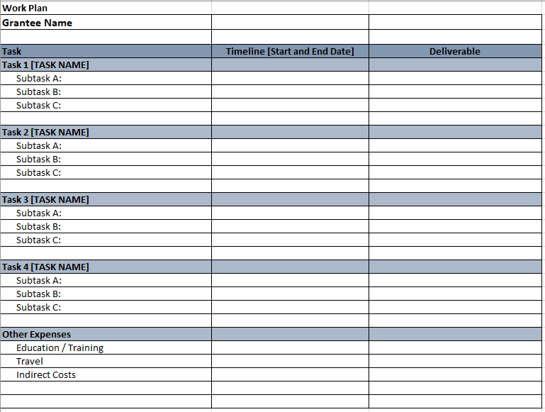

**Land Improvement Budget**

Applicants must provide a budget broken down by cost type and by task. Cost estimates should be consistent with the work plan. If awarded funding, this Budget will be detailed and incorporated into the Grant Agreement. The budget template can be found on the CFCP website. When submitting the budget with your application, submit as an excel document so staff can verify numbers and cost allocations. Do not convert the budget to a PDF.

