CALIFORNIA
SUSTAINABLE AGRICULTURAL LANDS CONSERVATION PROGRAM

Planning Grant Preproposal

STATE OF CALIFORNIA

STRATEGIC GROWTH COUNCIL

Final
February 2020

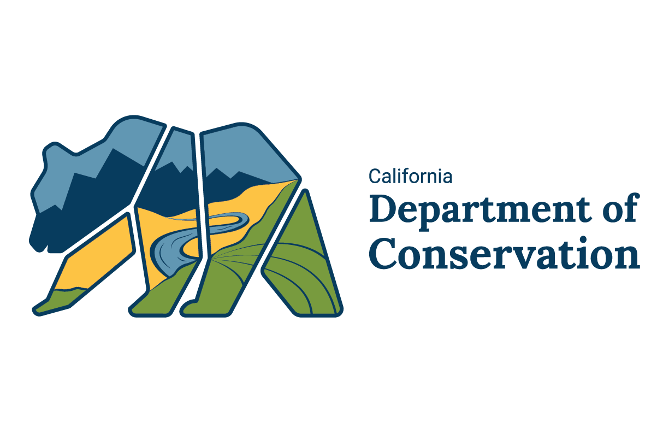
For additional information, please contact:

STRATEGIC GROWTH COUNCIL
(916) 322-2318
http://www.sgc.ca.gov/programs/salc/

California Department of Conservation
Division of Land Resource Protection
(916) 324-0850
http://www.conservation.ca.gov/dlrp

At-A-Glance

Program
The Sustainable Agricultural Lands Conservation Program is a component of the Strategic Growth Council’s Affordable Housing and Sustainable Communities Program. The Department of Conservation, in conjunction with the Natural Resources Agency, administers SALC on behalf of the Strategic Growth Council.

Funding Source
This program is funded through the California Climate Investments Program.

Critical Dates for Round 6 (proposed, subject to change)
Draft Guidelines released for comment December 20, 2019
Public comment closed January 27, 2020 12 p.m.
Guidelines adopted February 25, 2020
Acquisition Pre-proposal due April 30, 2020
Planning Pre-proposal due July 1, 2020
Determination of available funding September 2020
Full Applications due August 28, 2020
Project Awards December 2020

Contact for Questions
Department of Conservation
Division of Land Resource Protection
Virginia Jameson, Program Manager
salcp@conservation.ca.gov
(916) 324-0868

Submittal Requirements
All applicants are encouraged to provide the Department with a structured summary of their proposed project prior to the full application deadline.
By providing basic information about the potential project’s scope and goals, Department staff can provide preliminary technical assistance to the applicant in advance of completion of full project application.
Please submit the below form to the Department by email to salcp@conservation.ca.gov
Project Title
Applicant Name
Department/Office
Federal Employer ID Number
Mailing Address
Project Title:
Location (County and/or City)
Claiming Priority Population Benefits Status (circle one) | Y / N
If yes, you will need to submit a Priority Population Benefits Checklist with your application (not with this pre-proposal).
Grant Request Amount | $
Matching Funds Pending | $
Matching Funds Committed | $
Total Estimated Project Cost | $
Contact Person
Title
Phone Number
Email Address

Executive Summary and Proposed Planning Project
Please provide a brief overview of the project (1-page maximum). This overview should describe the following:
- Provide a brief description of the proposed planning project.
- Why the proposed project is appropriate for protecting agricultural lands in the jurisdiction.
- Participating stakeholders.
- Any critical deadlines.

Preproposal Questions
- Describe the proposed planning project. Include details such as the anticipated outcome and deliverables are expected; agricultural land base, economy, and regional food systems and infrastructure within the project area; amount and quality of agricultural land that can be expected to receive protection through the proposed project. Include maps of important farmland, jurisdictional boundaries, and other pertinent data that would portray the project scope (as attachments to the application).
- Why and to what extent agricultural land is being converted to other uses within project area? To what extent those conversion risks are expected to continue? How will the proposed project address those conversion risks?
- How will the project avoid or reduce greenhouse gas emissions?
- How will the proposed project implement an adopted or draft Sustainable Communities Strategy or, if a Sustainable Communities Strategy is not required for a region by law, a regional plan that includes policies and programs to reduce greenhouse gas emissions? Provide references to the specific goals, objectives, or policies that the project supports.
- How is the proposed plan consistent with California’s Planning Priorities?
- What economic, environmental, public health or other co-benefits that would arise from the project? How will those co-benefits be measured?
- How will the proposal complement other efforts in the region, including comprehensive planning efforts (e.g., Greenprints, general or special plan objectives or goals), and agricultural land use policies (e.g., Williamson Act)? How would the project leverage other permanently protected lands to promote location and resource-efficient development?
- What is the applicant’s experience in developing and implementing similar projects? What are the internal resources and capacity to complete the proposed work or will consultants or contractors be required? Are there professional staff qualified to develop and successfully implement the proposal? If not, please describe how will the applicant acquire this expertise.
- Which stakeholders will participate in the proposed project? How will these stakeholders participate?

Map(s) of the Project area
Please provide a map or image depicting the area to be covered by the proposed project. The map should generally depict the area, including the extent of its agricultural resources, urban and/or rural land uses, and any ancillary map data to support the need for the proposal. Examples of maps include Important Farmland Maps, Spheres of Influence, priority planning areas, and other protected lands. Protected lands databases can be found at the following locations:
National Conservation Easement Database
California Protected Area Database
California Conservation Easement Database
Maps or images must print into an 8 ½” x 11” sheet of paper.
Geographic information system (GIS) data may be submitted along with digital map products.

