If the Box.com page is blank when you access it, follow these steps to view data.
- First click on any of the District links:
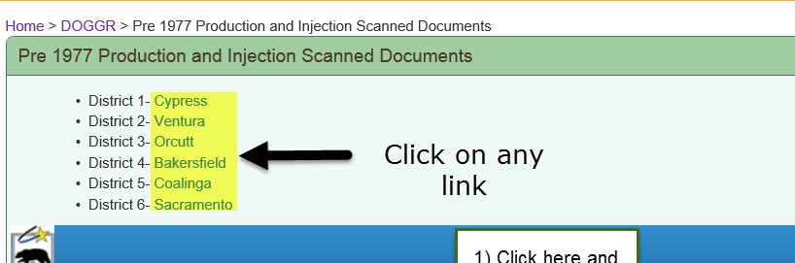

- If you find yourself on a box.com page that is blank, click the cog in the upper right hand corner: 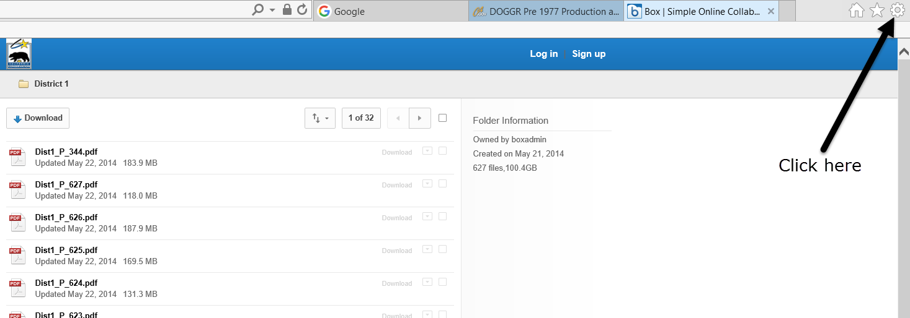
- From the expanded menu, select Internet options: 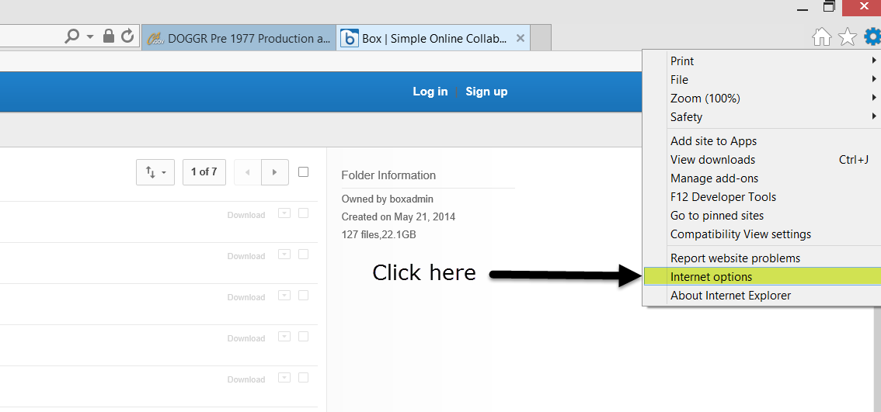
- When the Internet Options pop-up appears, click on the Security tab: 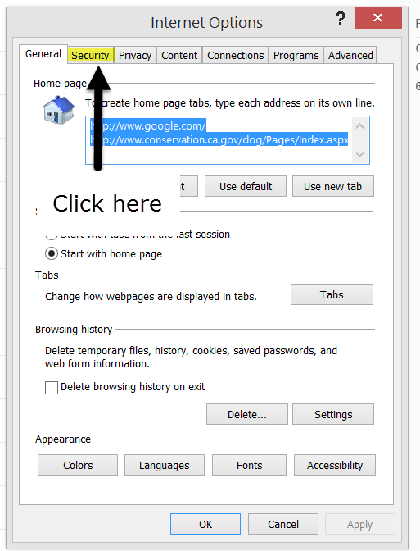
- From the Security tab, click on Trusted sites and then on Sites: 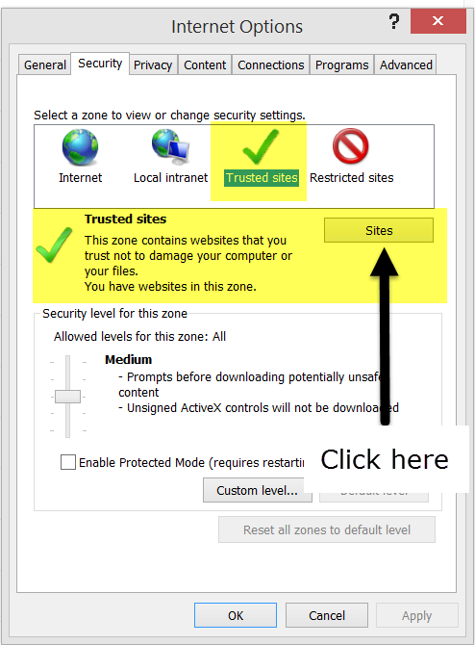
- To add all Box.com webpages, you will need to type https://*.box.com into the address box and click Add:
- Exit out of and restart your browser. You should be able to access box.com now, and if not, contact the DOGGR webmaster at: DOGGRwebmaster@conservation.ca.gov

